⚙️ Design & Technology Jokes ⚙️
20 Curriculum-Linked Jokes
Each joke connects to a key learning point

Contents
1. Why did the screwdriver feel important? [Tools and their mechanical advantages]
2. Why did the CAD drawing go to therapy? [CAD: Computer-Aided Design layers]
3. What's a woodworker's favourite day? [Working with timber: hardwoods, softwoods]
4. Why was the 3D printer always busy? [3D printing: additive manufacturing]
5. What did the designer say about their prototype? [Iterative design and prototyping]
6. Why did the soldering iron go on holiday? [Soldering: joining electronic components]
7. What's the strongest shape in construction? [Structural strength: triangulation]
8. Why was the design brief so short? [Writing design briefs and specifications]
9. What do you call a belt made of watches? [Mechanisms: gears, cams, levers]
10. Why did the student vacuum their workshop? [Workshop safety and risk assessment]
11. What material bounces back after being bent? [Thermoplastics vs thermosets]
12. Why did the circuit board blush? [Resistor colour codes in electronics]
13. What did the plywood say to the MDF? [Manufactured boards: plywood, MDF]
14. Why is ergonomics so comfortable? [Ergonomics: human-centred design]
15. What do you call a lazy saw? [Hand tools: hacksaw, coping saw, tenon saw]
16. Why was the exploded diagram so dramatic? [Exploded diagrams in technical drawing]
17. What did the dowel joint say to the butt joint? [Wood joints: dowel, mortise, tenon]
18. Why did the smart material change colour? [Smart materials: thermochromic, shape memory]
19. What's a designer's favourite question? [User-centred design and target markets]
20. Why did the student test their product? [Testing and evaluation in DT]

Joke #1
📌 Curriculum Link: Tools and their mechanical advantages

Q: Why did the screwdriver feel important?
A: Because it had a point — and torque!
💡 Discussion: Why is this joke funny? What does it tell us about "Tools and their mechanical advantages"? Can you explain the concept to a partner?

Joke #2
📌 Curriculum Link: CAD: Computer-Aided Design layers

Q: Why did the CAD drawing go to therapy?
A: It had too many layers of issues!
💡 Discussion: Why is this joke funny? What does it tell us about "CAD: Computer-Aided Design layers"? Can you explain the concept to a partner?

Joke #3
📌 Curriculum Link: Working with timber: hardwoods, softwoods

Q: What's a woodworker's favourite day?
A: Chews-day! (Tuesday)
💡 Discussion: Why is this joke funny? What does it tell us about "Working with timber: hardwoods, softwoods"? Can you explain the concept to a partner?

Joke #4
📌 Curriculum Link: 3D printing: additive manufacturing

Q: Why was the 3D printer always busy?
A: Because it was making layer after layer of progress!
💡 Discussion: Why is this joke funny? What does it tell us about "3D printing: additive manufacturing"? Can you explain the concept to a partner?

Joke #5
📌 Curriculum Link: Iterative design and prototyping

Q: What did the designer say about their prototype?
A: It's a work in progress — iteration is key!
💡 Discussion: Why is this joke funny? What does it tell us about "Iterative design and prototyping"? Can you explain the concept to a partner?

Joke #6
📌 Curriculum Link: Soldering: joining electronic components

Q: Why did the soldering iron go on holiday?
A: It needed to cool down!
💡 Discussion: Why is this joke funny? What does it tell us about "Soldering: joining electronic components"? Can you explain the concept to a partner?

Joke #7
📌 Curriculum Link: Structural strength: triangulation

Q: What's the strongest shape in construction?
A: A triangle — it doesn't collapse under pressure!
💡 Discussion: Why is this joke funny? What does it tell us about "Structural strength: triangulation"? Can you explain the concept to a partner?

Joke #8
📌 Curriculum Link: Writing design briefs and specifications

Q: Why was the design brief so short?
A: Because good briefs are clear and concise!
💡 Discussion: Why is this joke funny? What does it tell us about "Writing design briefs and specifications"? Can you explain the concept to a partner?

Joke #9
📌 Curriculum Link: Mechanisms: gears, cams, levers

Q: What do you call a belt made of watches?
A: A waist of time — but great for learning about mechanisms!
💡 Discussion: Why is this joke funny? What does it tell us about "Mechanisms: gears, cams, levers"? Can you explain the concept to a partner?

Joke #10
📌 Curriculum Link: Workshop safety and risk assessment

Q: Why did the student vacuum their workshop?
A: Because safety means keeping a clean workspace!
💡 Discussion: Why is this joke funny? What does it tell us about "Workshop safety and risk assessment"? Can you explain the concept to a partner?

Joke #11
📌 Curriculum Link: Thermoplastics vs thermosets

Q: What material bounces back after being bent?
A: A thermoplastic — it can be reshaped with heat!
💡 Discussion: Why is this joke funny? What does it tell us about "Thermoplastics vs thermosets"? Can you explain the concept to a partner?

Joke #12
📌 Curriculum Link: Resistor colour codes in electronics
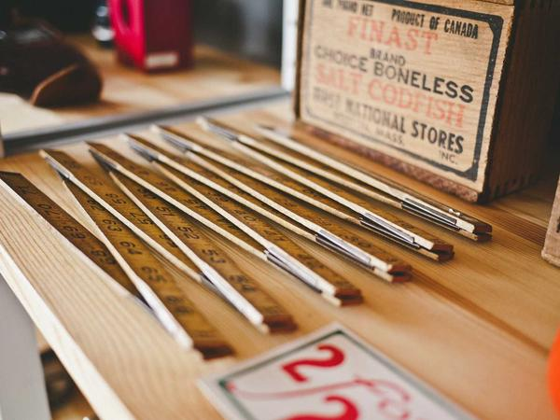
Q: Why did the circuit board blush?
A: Because it saw the resistor's true colours!
💡 Discussion: Why is this joke funny? What does it tell us about "Resistor colour codes in electronics"? Can you explain the concept to a partner?

Joke #13
📌 Curriculum Link: Manufactured boards: plywood, MDF

Q: What did the plywood say to the MDF?
A: We're both engineered, but I've got more layers!
💡 Discussion: Why is this joke funny? What does it tell us about "Manufactured boards: plywood, MDF"? Can you explain the concept to a partner?

Joke #14
📌 Curriculum Link: Ergonomics: human-centred design

Q: Why is ergonomics so comfortable?
A: Because it designs things to fit people, not the other way round!
💡 Discussion: Why is this joke funny? What does it tell us about "Ergonomics: human-centred design"? Can you explain the concept to a partner?

Joke #15
📌 Curriculum Link: Hand tools: hacksaw, coping saw, tenon saw

Q: What do you call a lazy saw?
A: A hack... saw!
💡 Discussion: Why is this joke funny? What does it tell us about "Hand tools: hacksaw, coping saw, tenon saw"? Can you explain the concept to a partner?

Joke #16
📌 Curriculum Link: Exploded diagrams in technical drawing

Q: Why was the exploded diagram so dramatic?
A: Because it showed everything falling apart — on purpose!
💡 Discussion: Why is this joke funny? What does it tell us about "Exploded diagrams in technical drawing"? Can you explain the concept to a partner?

Joke #17
📌 Curriculum Link: Wood joints: dowel, mortise, tenon

Q: What did the dowel joint say to the butt joint?
A: I'm stronger because I go deeper!
💡 Discussion: Why is this joke funny? What does it tell us about "Wood joints: dowel, mortise, tenon"? Can you explain the concept to a partner?

Joke #18
📌 Curriculum Link: Smart materials: thermochromic, shape memory

Q: Why did the smart material change colour?
A: Because it was a thermochromic — reacting to heat!
💡 Discussion: Why is this joke funny? What does it tell us about "Smart materials: thermochromic, shape memory"? Can you explain the concept to a partner?

Joke #19
📌 Curriculum Link: User-centred design and target markets

Q: What's a designer's favourite question?
A: Who is this for? — always consider the user!
💡 Discussion: Why is this joke funny? What does it tell us about "User-centred design and target markets"? Can you explain the concept to a partner?

Joke #20
📌 Curriculum Link: Testing and evaluation in DT

Q: Why did the student test their product?
A: To make sure it met the specification — quality control!
💡 Discussion: Why is this joke funny? What does it tell us about "Testing and evaluation in DT"? Can you explain the concept to a partner?

